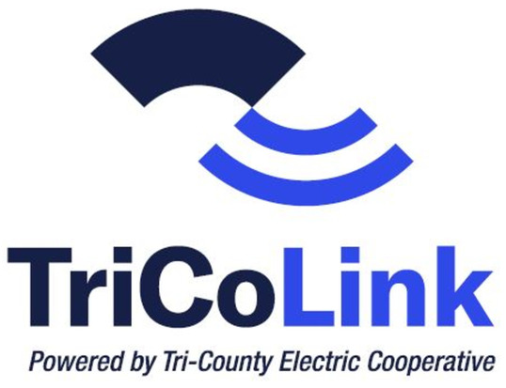

**TRICOLINK, INC.**

**PRIVACY POLICY**

***Contents***

1. Introduction
2. Information Collected
3. Use of Cookies
4. Sharing of Information
5. Email and Spam
6. Third Parties
7. Contact Information
8. Policy Changes

**I. INTRODUCTION**

Protecting your privacy is important to us. TRICOLINK, INC. hopes that the following statement will demonstrate our full commitment to privacy and help you understand how TRICOLINK, INC. collects, uses and safeguards any personal information you provide us from this website.

**II. INFORMATION COLLECTED**

TRICOLINK, INC. does not collect any personally identifiable information about you, such as name, address, phone number, or e-mail address.

Like most Internet sites, we do obtain some non-personally identifiable information such as the URL that referred you to our site, your Internet browser version, or type of operating system that you use. This information helps us analyze traffic patterns, perform routine maintenance, maintain site security, and is used solely for the purpose of improving our site navigation, measuring our advertising effectiveness and to improve the appearance of our site to the maximum number of visitors. Generally the information we collect is temporary and when you leave the site this information is deleted from our system.

Be assured that no personal information will ever be shared or sold by TRICOLINK, INC.

 II**I. USE OF COOKIES**

TRICOLINK, INC. sometimes uses "cookies" to enhance your experience on this web site.

Cookies cannot be used to personally identify you in any way. A cookie is a unique file that is stored on your computer. This cookie helps ensure that you don't repeatedly see the same advertisement, such as a pop-up ad window. Although the acceptance of cookies help us to enhance your stay at our site, they are not required to view our site.

If you do not want cookies, you can usually configure your Internet browser software to reject cookies or manually delete them. Consult your Internet browser's documentation for more information.

1. **SHARING OF INFORMATION**

Protecting your privacy is very important to us. TRICOLINK, INC. does not sell or share any type of personal information with anyone.

However, we cannot be responsible for the privacy practices of third-party sites. Please read the privacy policy section pertaining to [third party sites.](http://isp1.us/privacy/#_blank)

1. **EMAIL AND SPAM**

TRICOLINK, INC. sends no unsolicited or SPAM mail.

* If you need to be removed from an Internet service provider or other access provider's mailing list you will need to contact them directly.
* If you continue to receive SPAM, you may report it to the Federal Trade Commission. Send a copy of unwanted or deceptive messages to [spam@uce.gov](mailto:spam@uce.gov). The FTC uses the unsolicited emails stored in this database to pursue law enforcement actions against people who send deceptive spam email.
  + You may let the FTC know if a "remove me" request is not honored. If you want to complain about a removal link that doesn't work or not being able to unsubscribe from a list, you can fill out the FTC's online complaint form at [www.ftc.gov](http://www.ftc.gov/). Your complaint will be added to the FTC's Consumer Sentinel database and made available to hundreds of law enforcement and consumer protection agencies.
  + Whenever you complain about spam, it's important to include the full email header. The information in the header makes it possible for consumer protection agencies to follow up on your complaint.

1. **THIRD PARTIES**

* TRICOLINK, INC. ’s site may contain links to third party sites. We are not responsible for the privacy practices of third-party sites. Once you leave our site we have no control over your privacy.
* Third-party resources that can be accessed with hypertext links from this web site are not under our control, and TRICOLINK, INC. is not responsible for the contents of any of these third-party resources. The third-party links on this site are provided for your convenience only.
* The inclusion of any link on this site does not imply any specific recommendation, approval or endorsement of the third party.
* Please investigate any third party offers found here with their respective companies and make your own informed decisions. Review the privacy statements of each web site you visit to ensure your personal privacy with respect to third party offers.
* The privacy information contained here pertains exclusively to the TRICOLINK, INC. web site.

**VII. CONTACT INFORMATION**

We welcome questions regarding our privacy policy. Customers with complaints or questions relating to our privacy policy or these disclosures can contact us at:

Email:[TriCoLink@tce.coop](mailto:TriCoLink@tce.coop) [or Call](tel:877-546-5823): 877-LINKTCE ([877-546-5823](tel:877-546-5823))

[A customer always has the right to file a complaint with the Federal Communications Commission at www.fcc.gov.](tel:877-546-5823)

[**VIII. POLICY CHANGES**](tel:877-546-5823)

[Any changes to our privacy policy will be posted here. Continued use of the TRICOLINK, INC. web site implies that you understand and agree with our privacy policy.](tel:877-546-5823)