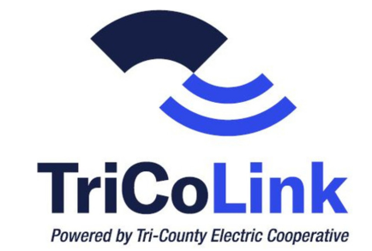

Battery Backup Requirements

Backup Power for Home Phone Services during Power Outages
For many years, your home phone would allow you to stay connected to emergency voice services during a power outage. However, many of today’s advanced home phone services require backup battery power to continue functioning during an outage. To avoid a disruption of home voice service during an outage – and to maintain the ability to connect to 911 emergency services -- we at TRICOLINK, INC. offer you the option of purchasing backup power for your home phones.

What Your Battery Can – and Can’t – Do for You
TRICOLINK, INC. ’s backup batteries for optical network terminals allow you to continue to use your home voice services during a power outage. Without a backup battery or alternate backup source such as a generator, customers will not be able to make any calls, including emergency calls to 911. The only way to maintain the ability to use your phone is by using some form of backup power.
Our backup battery does not provide power to any services other than voice. Home security systems, medical monitoring devices and other equipment will not run on a home phone backup battery.

Purchase and Replacement Options
If you are concerned about being able to contact 911 emergency services during a power outage, a backup battery may be a good option for you. The battery offered TRICOLINK, INC. is approximately [one pound] and is roughly the size of [a juice box].
-If the company provides the backup batteries-
You can purchase a backup battery directly through TRICOLINK, INC. If you have any questions or simply want to purchase a backup battery through us, please call 877-LINKTCE (877-546-5823) visit our website at https://tricolinksc.com/ or go to your local office. Our 24-hour backup batteries cost approximately [$100] and can be shipped directly to your house or can be picked up in one of our office locations. If you do not feel comfortable installing your own battery, please call us to make an appointment, and we would be happy to assist you. However, please note that there may be a charge for this service.
-If a third party provides the backup batteries-
You can also purchase a backup battery through many of your local retailers or on-line, including from the vendor identified below. Be sure to purchase the battery model that matches the type of equipment that you have. Call 877-LINKTCE (877-546-5823) to verify the type of device that you have.
Expected Backup Power Duration
Backup batteries are expected to last at least 24 hours on standby power. The backup battery should give you [10 hours] of usage time. If you feel that is not enough time, you may extend your standby power by purchasing additional 8 hour batteries.

Instructions for Proper Care and Use of Your Battery
Please follow the more detailed instructions included with your battery for proper use, storage and care of your battery to ensure that it will function as needed during a power outage. If you do not store your battery correctly, it may shorten its useful life. Environmental factors such as temperature can shorten your battery’s useful life. We recommend that you store your battery above [41°F and below 104°F].
These batteries are [not] rechargeable. They will not last forever and should be replaced every [1 to 2 years], or when your device starts to make a loud beeping sound. That sound means that the battery is depleted and must be replaced. See the instructions above for purchase and replacement options. You should also periodically, as described in the instructions included with your battery, remove and test your battery to verify both the operation of the backup battery and its condition.

